PICAP Procedure for Peer Review

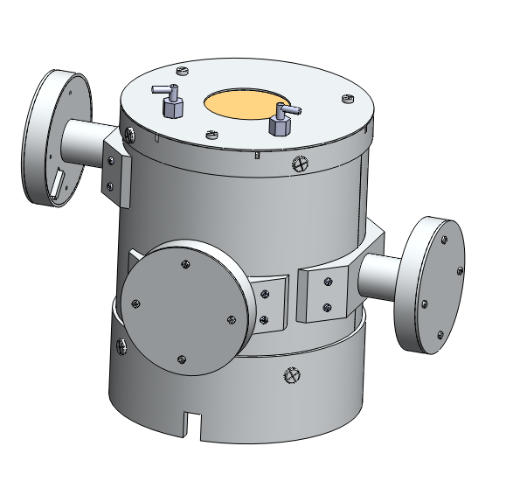

This is the design review assembly procedure for the PICAP telescope.

The purpose of this assembly procedure is to provide a basic visual aide during the peer review.

Note: The bordered pictures are not steps, these are final pictures of each sub assembly

# 1. Sub assemblies

# S1. PMT sub Assembly

# 

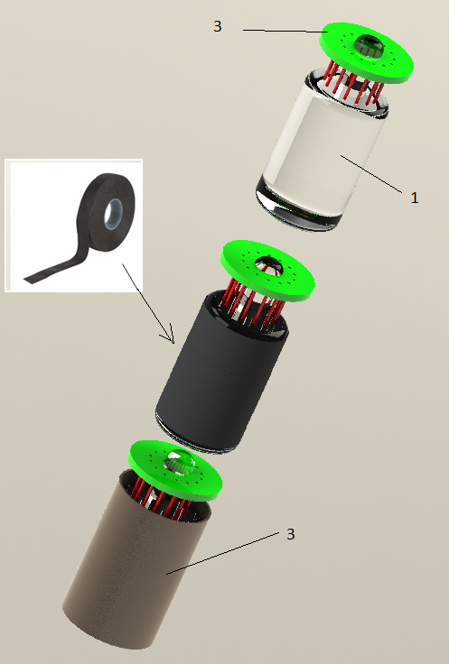

1 Solder daughter board onto PMT leads

2 Friction hold PMT in Mu metal Shield with Black tape

# S2. PMT Mushroom sub-assembly

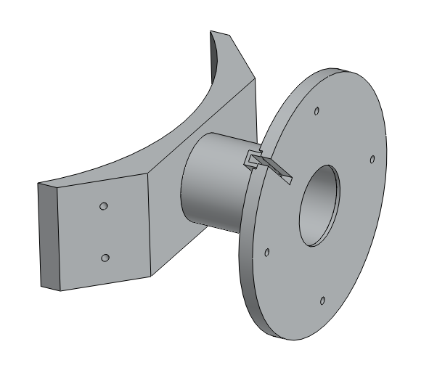

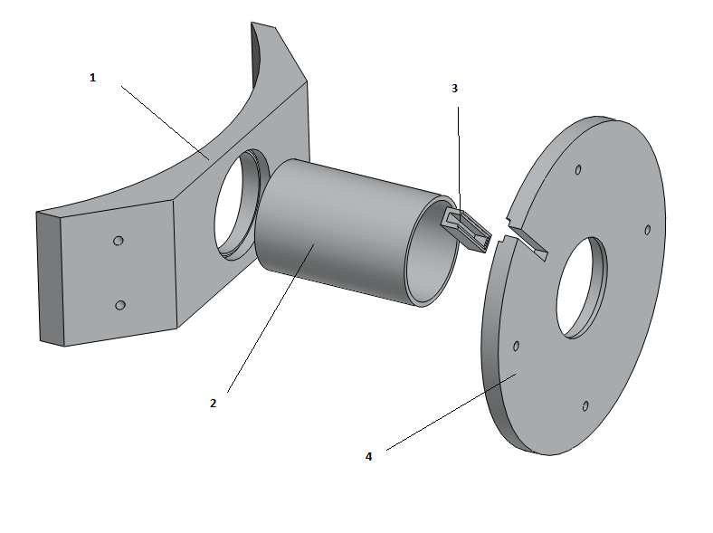

1 Epoxy Wire guard (3) onto circular aluminum base (4)

3 Epoxy Aluminum cylinder (2) into onto circular aluminum base (4)

4Epoxy Aluminum cylinder (2) into Base plate (1)

# 

# S3. Base Sub Assembly

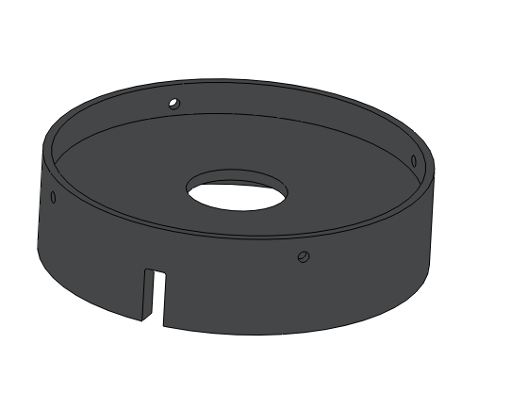

# 

1 Epoxy Circular plate (1) onto the hinge of the base (2)

# S4. Aluminum cylinder sub-assembly

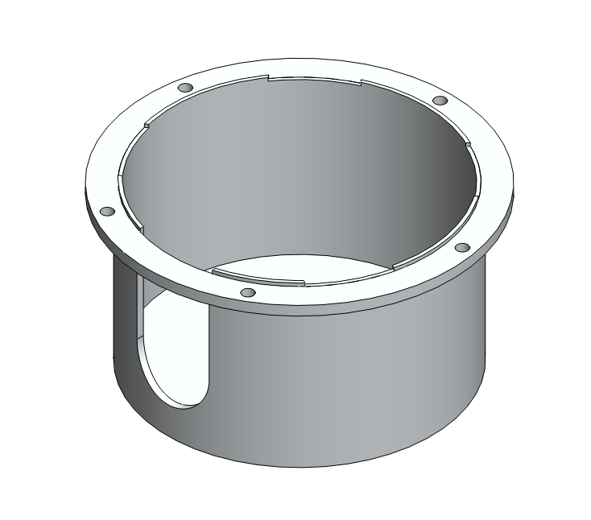

## 

1 Epoxy Aluminum cylinder to bottom plate. let sit until dry.

2 Epoxy flanges onto Aluminum cylinder

# S5. Mushroom cup

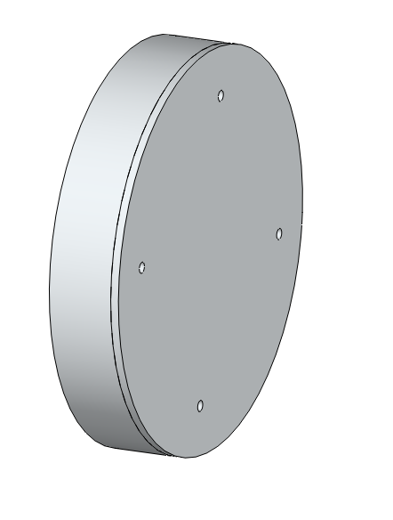

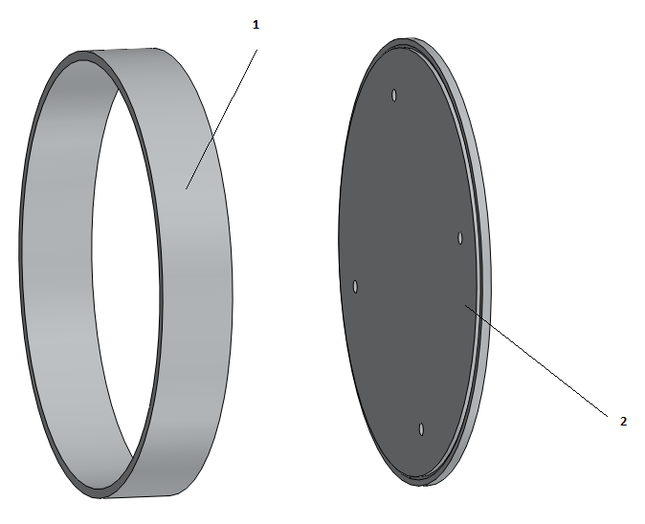

1 Epoxy Aluminum cylinder (1) to bottom plate (2) let sit until dry.

# 2. Scintillator Assembly

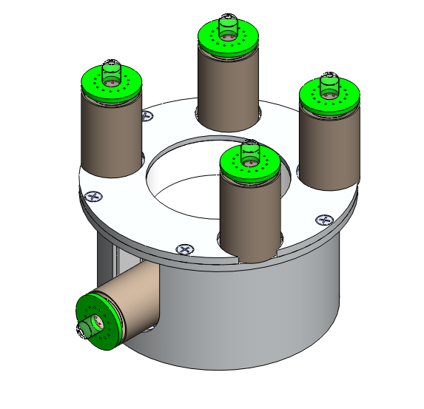

## 2.1 C scintillator sub-assembly

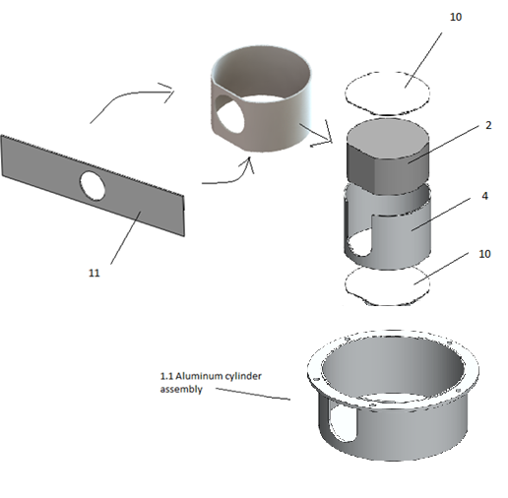

1 Place inner aluminum cylinder (4) into Current assembly

2 Place Teflon (10) into the inner aluminum cylinder (4)

3 Wrap Teflon foil (11) around C scintillator (2) drop into inner aluminum cylinder (4)

4 Place Teflon (10) into the inner aluminum cylinder (4) on top of the C scintillator (2)

## 2.2 Side PMT

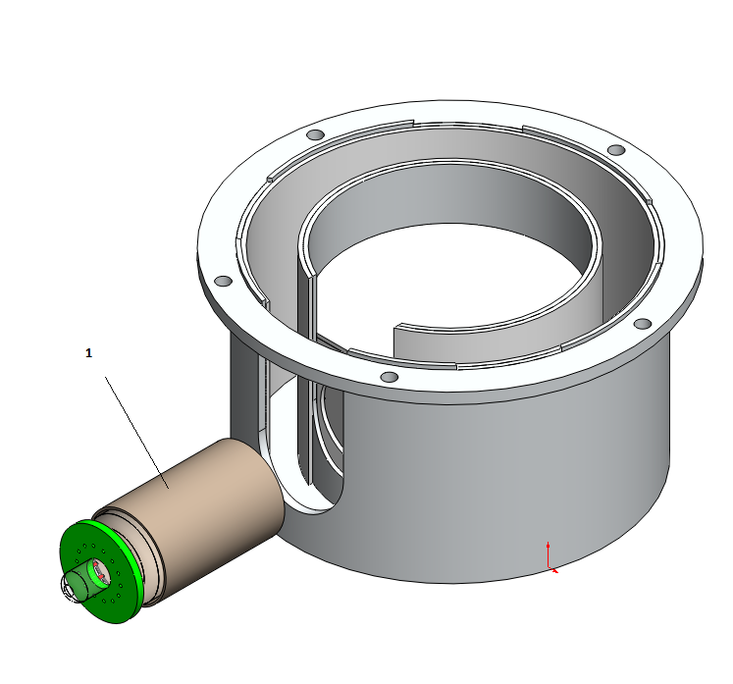

1 PTV PMT assembly (1) onto the C scintillaor through the hole of the Teflon

## 2.3 G scintillator sub-assembly

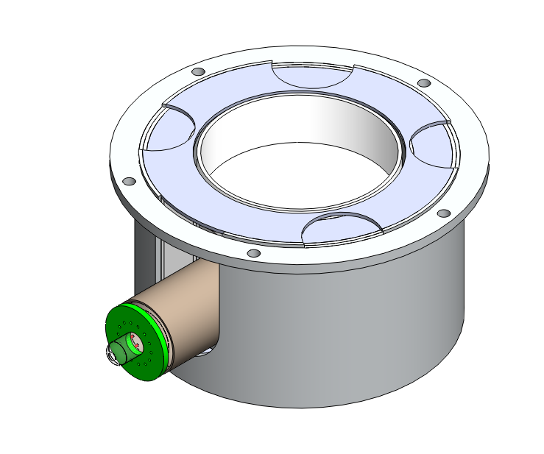

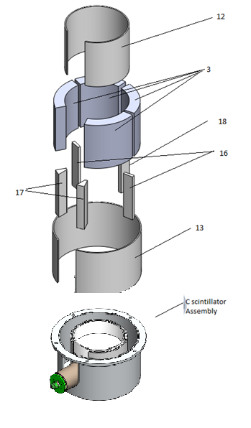

1 Place outer Teflon ring (13) into Current assembly

2 Place G-scintillators (3) into the current assembly between outer Teflon ring (13) and intter aluminum cylinder in the current assembly

3 place inner Teflon ring (12) in-between G-scintillators (3) and the intter aluminum cylinder in the current assembly

4 Place Teflon bars (16,17,18) between G-scintillators (3) in the order given below

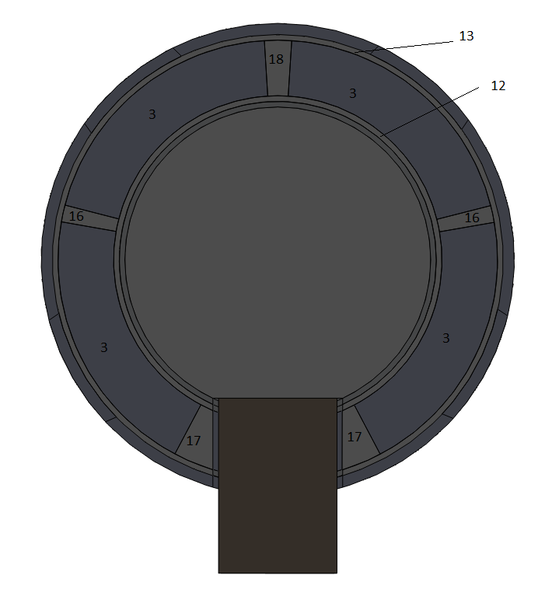

## 2.4 PMT sub-assembly

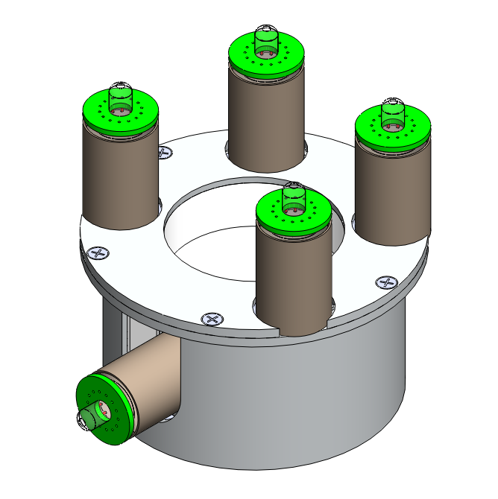

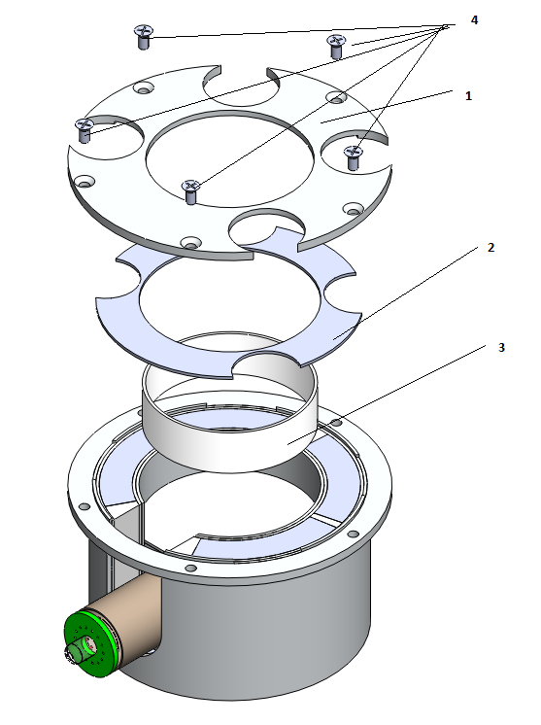

1 Place Plastic support ring (3) in the center of the inner aluminum cylinder

2 Place Teflon cover ring (2) on top of G-sintilators

3 Place Cover (1) on top of full assembly and screw in with M2 screws

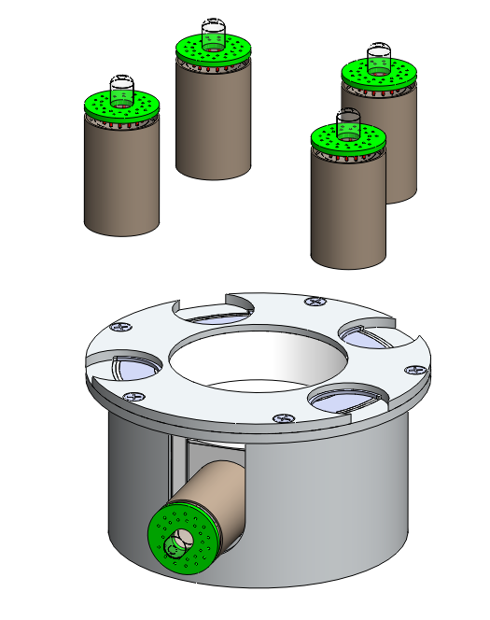

4 PVT PMT assemblies onto G-sintillators

# 3.0 Side Anti-Plastic assembly

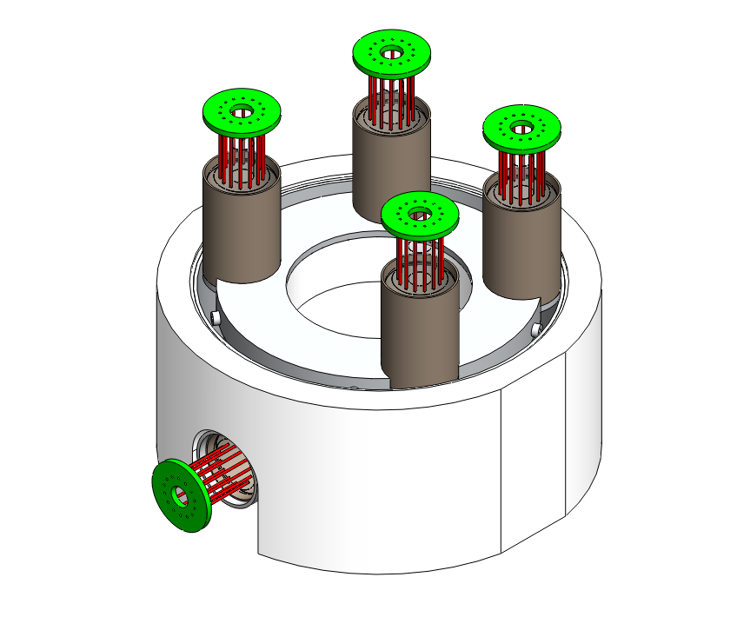

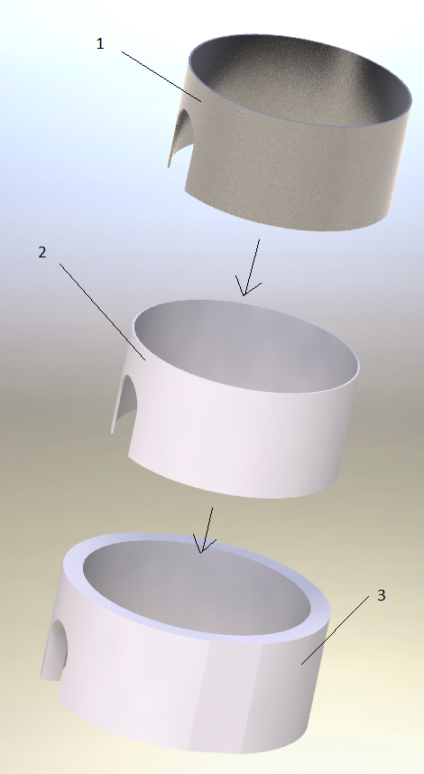

1 Place Teflon ring (2) into Outer Anti Plastic (3)

2 place aluminum cylinder (1) into the center of the Teflon ring (2)

# 

3 Place all 3 pieces around the current full assembly

# 4.0 Top Anti Plastic assembly

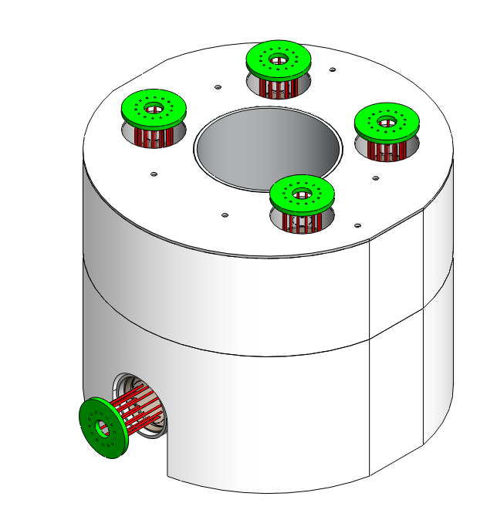

# 

1 Place Teflon cover ring (5) onto the cover of the current assembly

2 Place top Anti plastic (4) onto side anti plastic and Teflon cover ring (5)

3 Place Teflon ring (2) into the center of top Anti plastic (4)

4 Place Aluminum cylinder (3) in the center of Teflon ring (2)

5 Place the four Teflon rings (1) around each of the four mu-metal shields in the top Anti plastic (4)

# 5.0 Top Circuit board assembly

# 

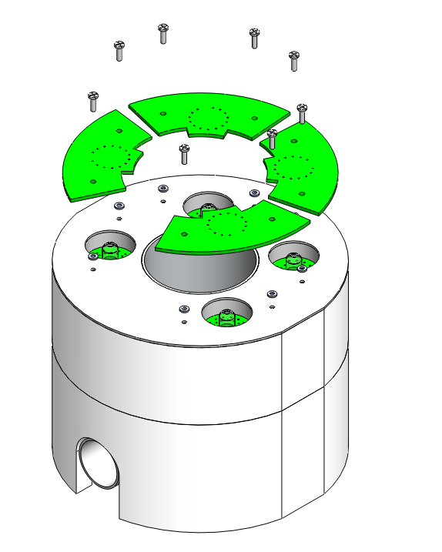

1 Align Pins of mother and daughter circuit boards

2 Align spacers with through holes of mother circuit boards

3 Screw in Circuit boards with Nylon M2 screws

# 5.0 Cover assembly

# 

## 5.1 Column assembly

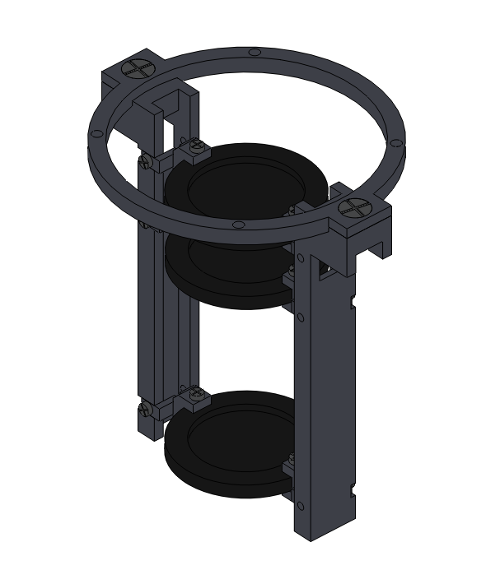

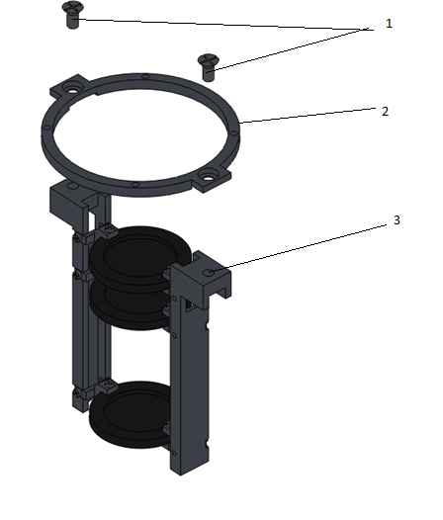

1 Screw aluminum ring (2) onto Column assembly (3) with counter sunk M3 screws (1)

## 5.2 Top cover assembly

# 

# 

1 Screw column assembly (2) onto Cover (3) with M2 screw s (1)

# 6.0 Adding cover to full assembly

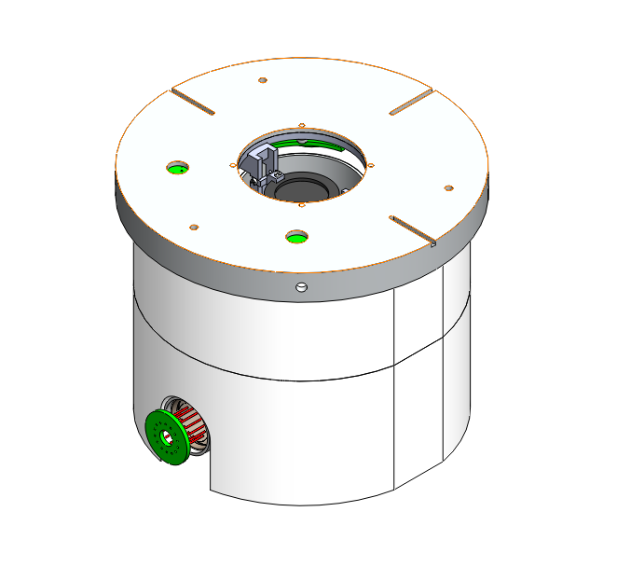

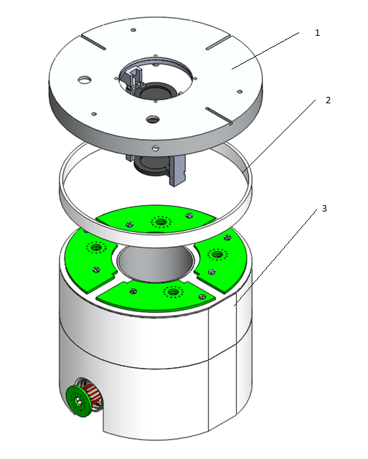

1 Place Plastic place holder ring (2) on top of the Top anit Plastic in the current assembly (3)

2 Place Cover assembly (1) on top of place holder ring (2)

# 7.0 Outer Cylinder assembly

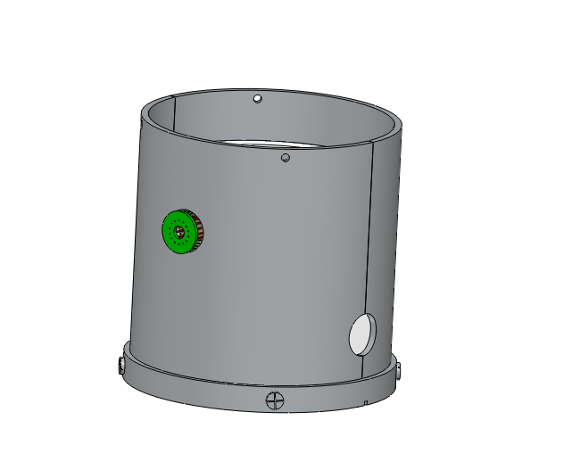

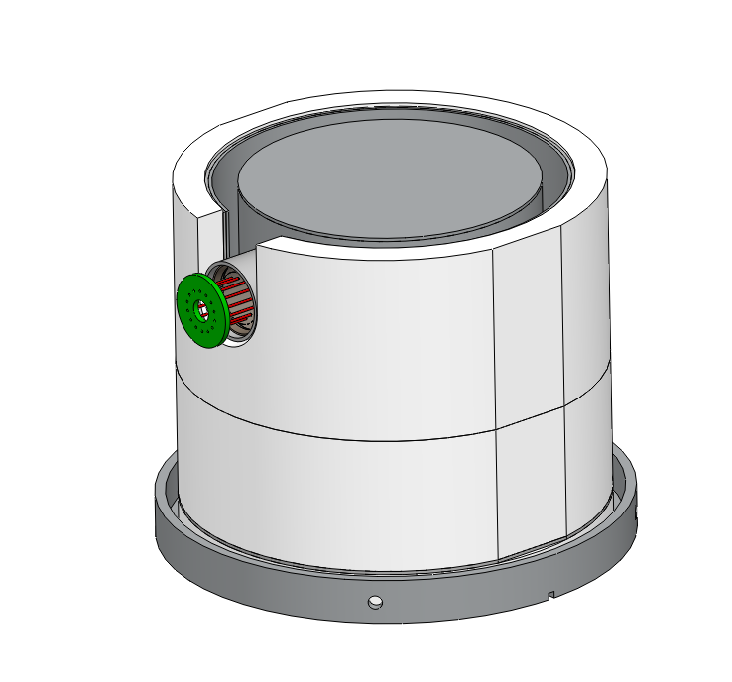

1 Flip entire assembly

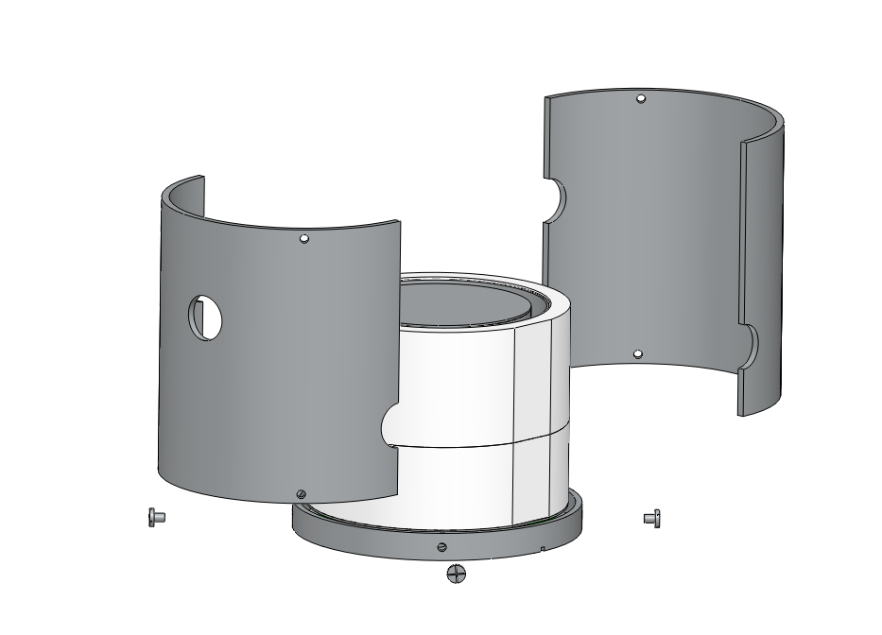

1 Place aluminum Cylinder halves around Anti sintillator and screw with M4 screws

# 8.0 Bottom cover assembly

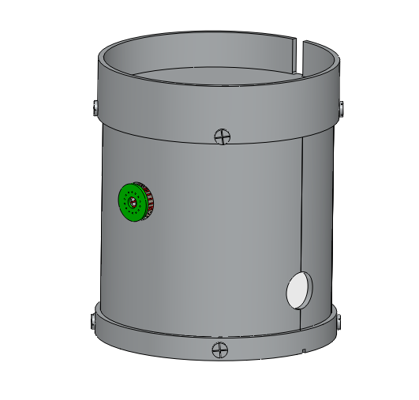

## 8.1 Bottom anti - Scintillator sub assembly

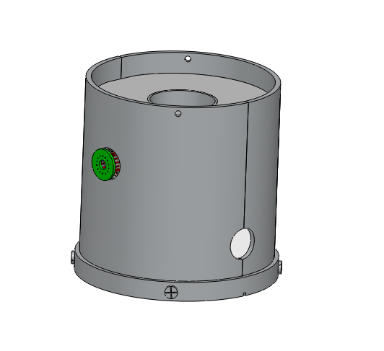

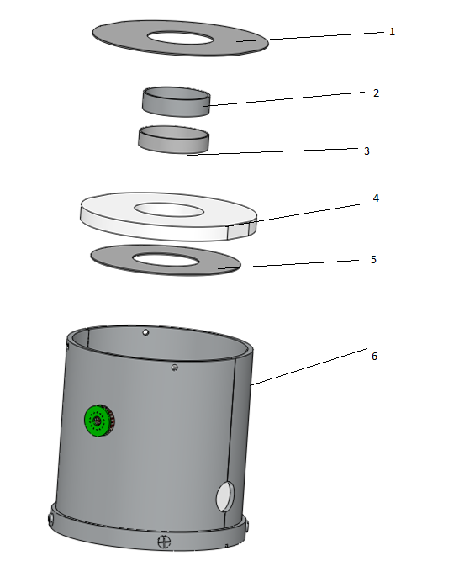

1 Place Teflon Cover ring (5) on the aluminum base in the current assembly (6)

2 Place bottom Anti plastic (4) on the side Anti plastic in current assembly (6)

3 Place the Teflon ring (3) in the center of Anti plastic (4)

4 Place the Aluminum ring (2) in the center of the Teflon ring (3)

5 Place the Teflon Ring cover (1) onto the Bottom anit plastic (4)

## 8.2 D4 sub assembly

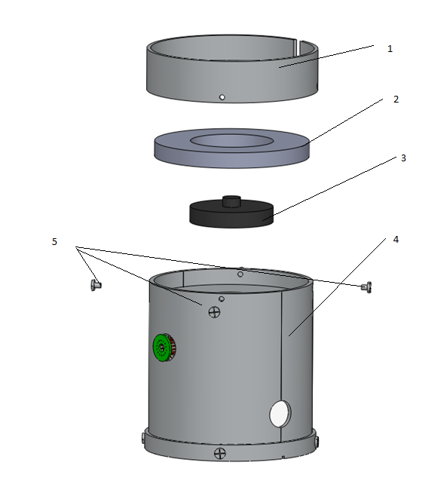

1 Place Plastic ring (2) into the current assembly (4)

2 Place D4 (3) into the center Plastic (2)

3 Place Base Assembly (1) on current assembly and screw with 4 M4 screws (5)

4 Flip whole assembly

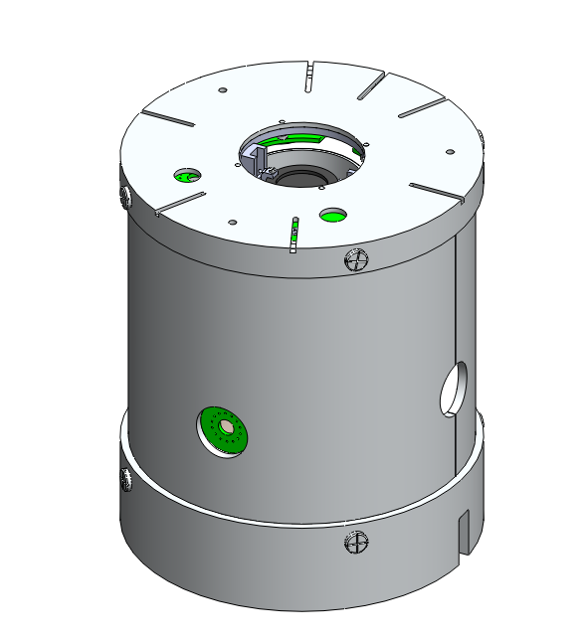

# 9.0 Brass foil assembly

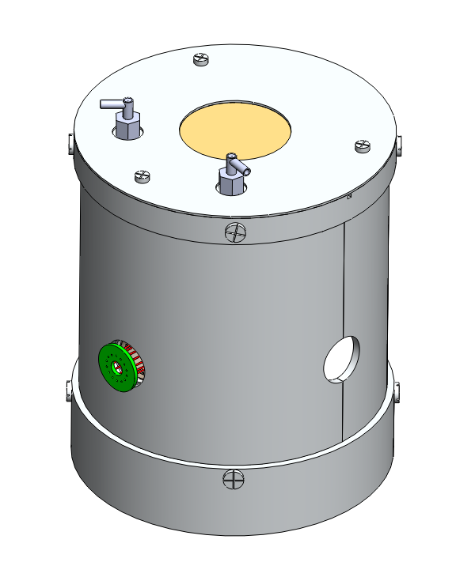

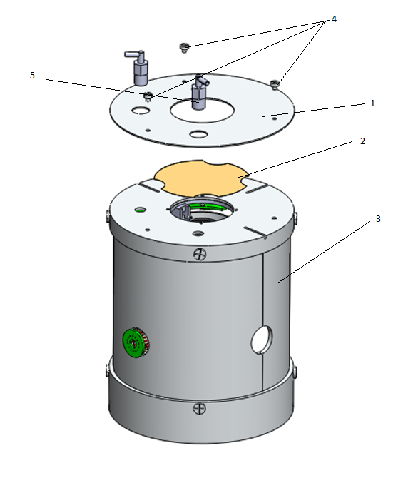

1 Place Brass foil (2) onto the cover of the Current assembly (3)

2 Place the top of the aluminum cover (1) top of the Brass foil (2) and cover of the Current assembly (30 and screw in with M3 screws (4)

3 Screw in the 90 degree vent ports (5) into the cover in the Current assembly (3) (top of the aluminum cover (1) is a through hole)

# 10.0 Side PMT assembly

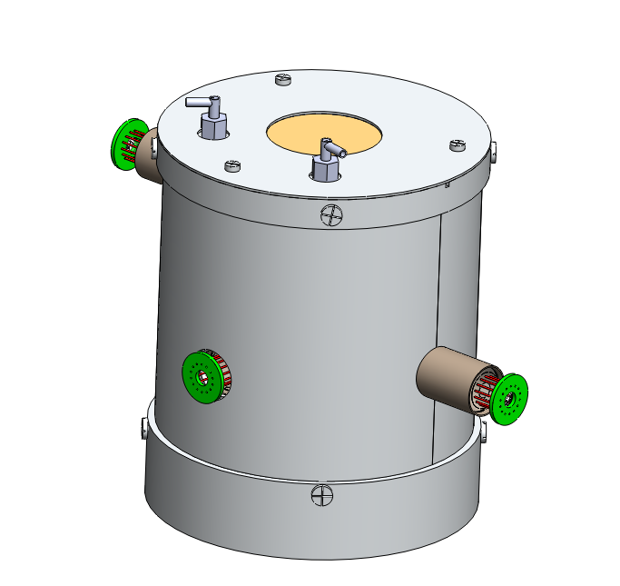

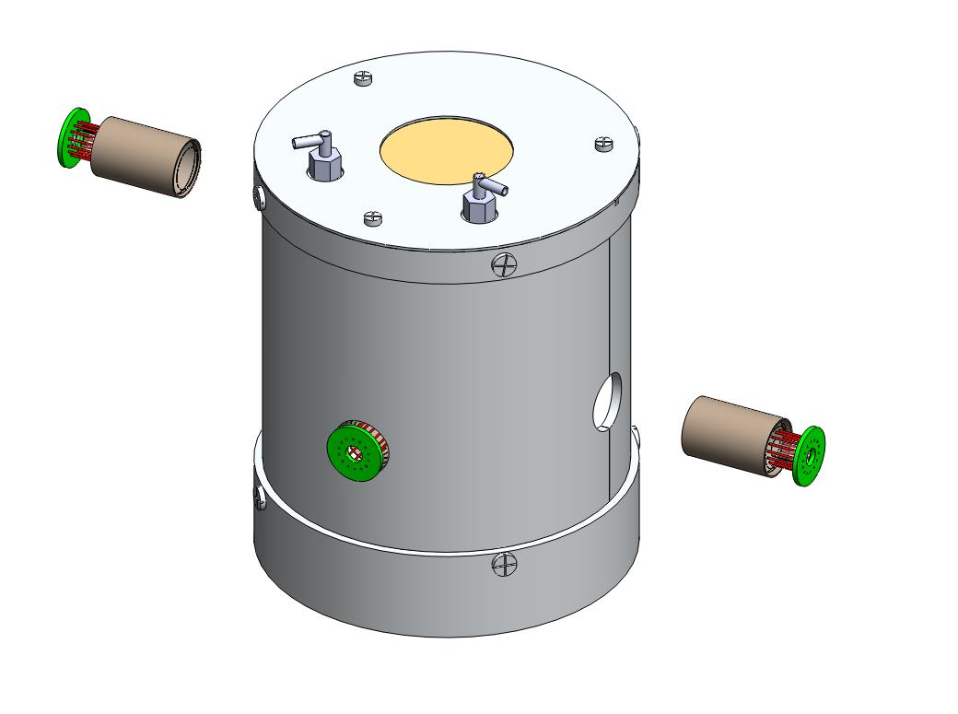

1 PTV The two PMT assemblies to the side of the anti plastic

# 12.0 Mushroom plate assembly

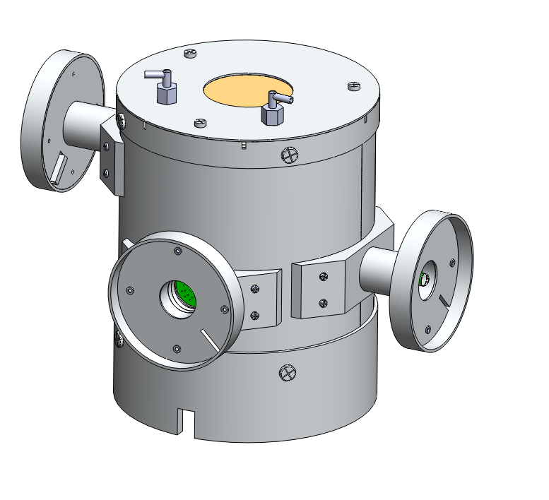

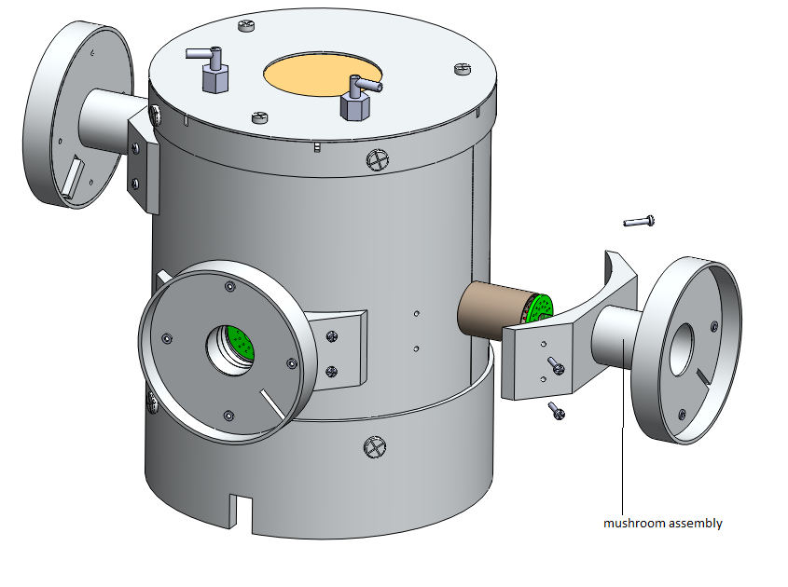

1 screw mushroom assembly onto current PICAP assembly

# 13.0 Side PMT Circuit board assembly



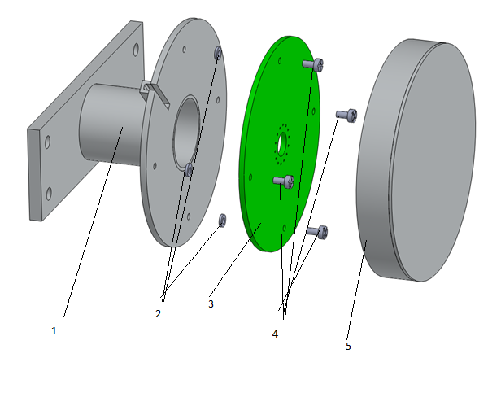

1 Align spacers (2) with through holes in the circuit board (3) and screw in with M2 screws (4)

2 Screw cover (5) onto Mushroom assembly (1)